

**Currency Derivatives Segment**

Circular No: MCCIL/CDS/2244/2022 15th July 2022

**Sub: CDS Settlement Schedule for August 2022**

In terms of the provisions of the Rules, Byelaws and Regulations of the Clearing Corporation, Clearing Members are hereby notified as under:

The Settlement schedule for the month of August 2022 will be as follows:

|  |  |
| --- | --- |
| **Trade Date** | **Settlement Date** |
| 01-Aug-22 | 02-Aug-22 |
| 02-Aug-22 | 03-Aug-22 |
| 03-Aug-22 | 04-Aug-22 |
| 04-Aug-22 | 05-Aug-22 |
| 05-Aug-22 | 08-Aug-22 |
| 08-Aug-22 | 10-Aug-22 |
| 10-Aug-22 | 11-Aug-22 |
| 11-Aug-22 | 12-Aug-22 |
| 12-Aug-22 | 17-Aug-22 |
| 17-Aug-22 | 18-Aug-22 |
| 18-Aug-22 | 19-Aug-22 |
| 19-Aug-22 | 22-Aug-22 |
| 22-Aug-22 | 23-Aug-22 |
| 23-Aug-22 | 24-Aug-22 |
| 24-Aug-22 | 25-Aug-22 |
| **\*** 25-Aug-22 | 26-Aug-22 |
| **\* \***26-Aug-22 | 29-Aug-22 |
| 29-Aug-22 | 30-Aug-22 |
| 30-Aug-22 | 01-Sep-22 |

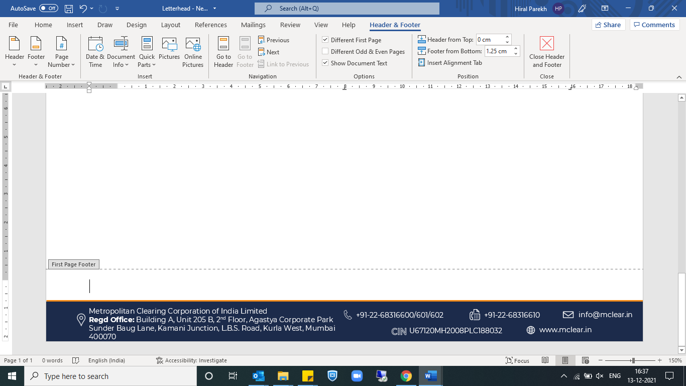



*The last trade date for IRF contracts expiring in the month of August will be August 25, 2022, and the final settlement of the same shall be done on August 26th, 2022.

**The last trade date for Currency Derivatives contracts, expiring in the month of August 2022 will be August 26th, 2022.The final settlement of the same shall be done on August 30th, 2022.

For clarifications, members may contact Customer Service on **022-68316600** or send an email to **info@mclear.in**

For and on behalf of

**Metropolitan Clearing Corporation of India Limited**

**Shweta Bhatt**

**Sr. Manager**

